LEX Program to Count Uppercase and Lowercase Characters

AIM:
To write a LEX program to read user input and count uppercase and lowercase alphabetic characters.

PSEUDOCODE:
- Start the program.
- Initialize uppercase and lowercase counts to zero.
- Read text entered by the user.
- Count uppercase letters (A–Z).
- Count lowercase letters (a–z).
- Display both counts.
- Stop the program.

Program:

%{
#include <stdio.h>
int upper = 0, lower = 0;
%}

%%
[A-Z] { upper++; }
[a-z] { lower++; }
.|\n ;
%%

int main()
{
printf("Enter text (press Ctrl+D to finish):\n");
yylex();

printf("Uppercase characters: %d\n", upper);
printf("Lowercase characters: %d\n", lower);

return 0;
}

int yywrap()
{
return 1;
}

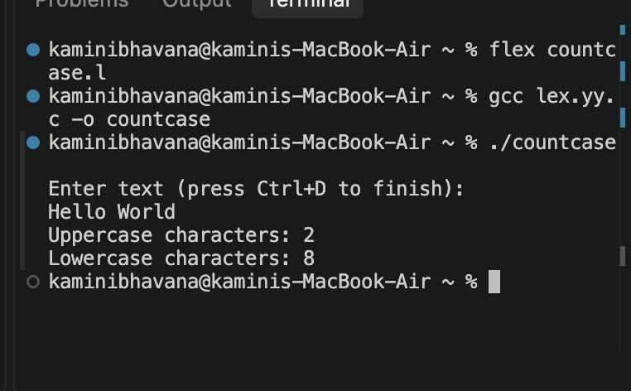
OUTPUT:

Result:
Thus, the LEX program was successfully implemented to accept user input and count uppercase and lowercase alphabetic characters.

